🟢 Bandit Level 1 → Level 2
After logging in as bandit1, run:
ls -al to list all the hidden files
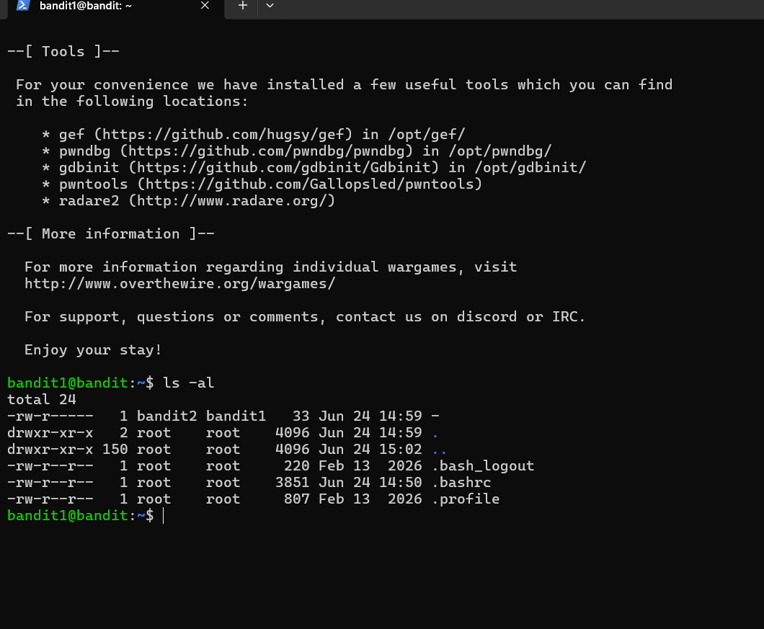
You'll see a file named:
-
Because - has a special meaning in Linux commands, use:
cat ./-
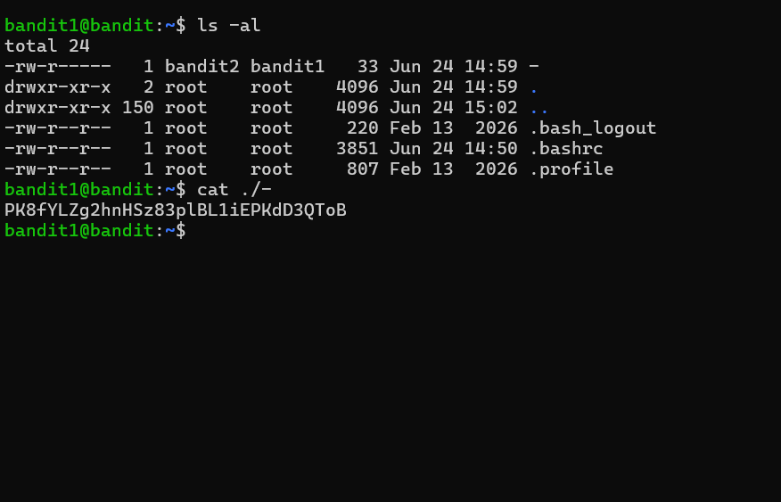
🔑 The output is the password for bandit2 is PK8fYLZg2hnHSz83plBL1iEPKdD3QToB
Then exit from that level

